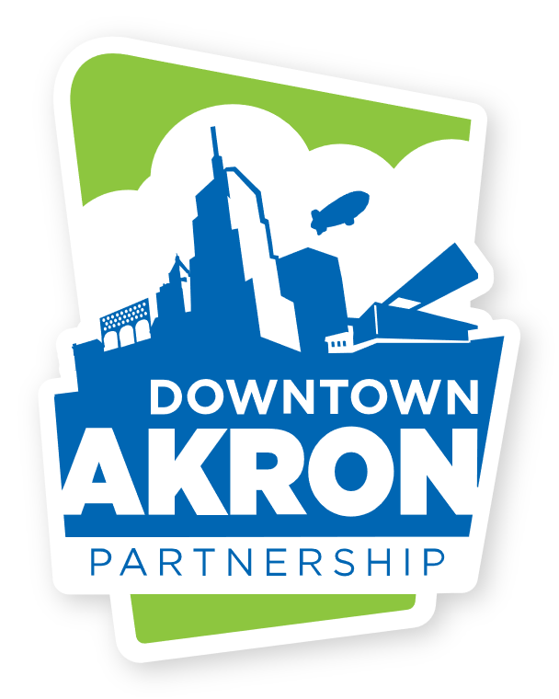

Greystone Hall Media Contact: Dominic Caruso,

103 S. High St., 4th floor Communications Director

Akron, Ohio 44308 dcaruso@downtownakron.com

www.downtownakron.com Office: 330-374-7676

**Media Advisory:**

**Akron Celebrates Latin Culture with the Fourth Annual Latin Festival, Saturday**

**AKRON, Ohio – Oct. 3, 2024 –**

What: Fourth Annual Akron Latin Festival

Who: Hosted by Downtown Akron Partnership and Proyecto Raíces. Performances by Grupo Fuego, Luka y su Ropa Vieja, and Azteca. Food vendors include Jonny Lote’s Latin Street Corn, Freaky Fruits, La Reina Boricua LLC, and more.

Where: Cascade Plaza, 122 S Main St, Akron, OH 44308

When: October 5, 2024, from 4:00 PM to 9:00 PM

Why: To celebrate the vibrant Latin community in and around downtown Akron.

How: Admission is free, and the event is open to all ages.

Media Information: Photography and videography are encouraged. Media members interested in setting up cameras near the stage can prearrange access by contacting Dominic Caruso at [dcaruso@downtownakron.com](mailto:dcaruso@downtownakron.com) or 330-374-7676.

Visuals: Grupo Fuego: 2024 Cleveland Music Award winners for Best Latin Group, performing with live instruments including saxophone, trumpet, guitar, keyboard, and a variety of traditional drums. Luka y su Ropa Vieja: Performing both contemporary and classic Latin hits with salsa, bachata, merengue, and reggaeton rhythms. The group features a dynamic female lead singer, acoustic and electric guitars, and traditional drums. Azteca Dance Group: A visually captivating performance showcasing dancers in traditional Aztec costumes adorned with feathered headdresses, gold, and beads.

Downtown Akron Partnership is a 501(c)3, non-profit organization that was originally founded in 1996. Ever since then, DAP has had a mission of enhancing the downtown environment by supporting the existing community and developing new, innovative programs designed to create interest in and attract people to the community of downtown Akron. Downtown Akron Partnership is run by a diverse board of directors that has Akron’s best interest at heart. [www.downtownakronpartnership.com](http://www.downtownakronpartnership.com)

**###**