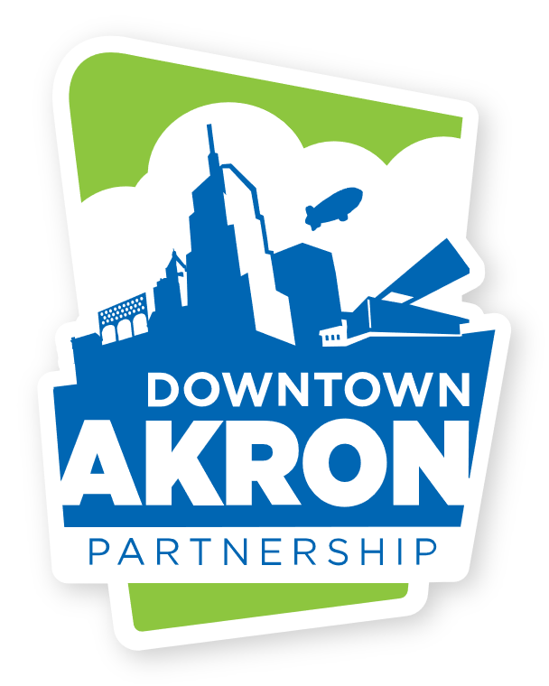

Greystone Hall **FOR IMMEDIATE RELEASE**

103 S. High St., 4th floor Media Contact: Dominic Caruso,

Akron, Ohio 44308 Communications Director

www.downtownakron.com dcaruso@downtownakron.com

Office: 330-374-7676

**Downtown Akron Partnership and Proyecto Raices present the 4th Annual Latin festival bringing music, food, and culture to Cascade Plaza.**

*The festival features live performances from Grupo Fuego and Luka y su Ropa Vieja as well as authentic Latin American cuisine from Jonny Lote’s Latin Street Corn, Freaky Fruits, La Reina Boricua LLC, and more.*

**AKRON, Ohio – Sept. 17, 2024 –** Downtown Akron Partnership and Proyecto Raices present the 4th Annual Akron Latin Festival on Saturday, October 5, from 4 to 9 p.m. at Cascade Plaza. The event will feature live performances by Grupo Fuego (2024 winners of the Cleveland Music Award for Best Latin Group), Luka y su Ropa Vieja, and Azteca, along with food, vendors, and cultural displays. Admission is free, and the event celebrates the Latin community in and around Downtown Akron.

“We’re thrilled to host the 4th Annual Akron Latin Festival and see it continue to grow each year,” said ____ of Downtown Akron Partnership. “This event is a wonderful opportunity to celebrate Latin culture in Akron, and we are excited to bring together music, food, and art to Cascade Plaza for everyone to enjoy.”

The festival will offer a rich selection of authentic Latin American cuisine and artisanal goods. Indulge in unique treats like elótes and nachos from Johnny Lóte’s Latin Street Corn, fresh-cut fruit with delicious toppings from Freaky Fruits, and savory Puerto Rican dishes from La Reina Boricua LLC. Along with the incredible food, attendees can explore a variety of vendors such as Ali's Artesania Taina, showcasing traditional Puerto Rican woodcrafts, Clairescreations89's colorful handmade crochet pieces, and Latin Minga's artisan products crafted by Latin women and brought to the U.S. The marketplace is sure to provide a vibrant and immersive cultural experience.

Downtown Akron Partnership is a 501(c)3, non-profit organization that was originally founded in 1996. Ever since then, DAP has had a mission of enhancing the downtown environment by supporting the existing community and developing new, innovative programs designed to create interest in and attract people to the community of downtown Akron. Downtown Akron Partnership is run by a diverse board of directors that has Akron’s best interest at heart. [www.downtownakronpartnership.com](http://www.downtownakronpartnership.com)

**###**