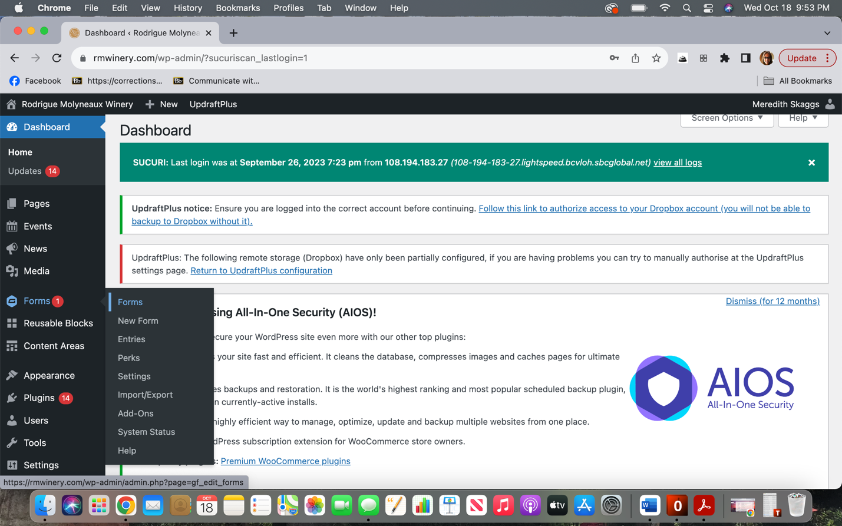

1. Click on Forms

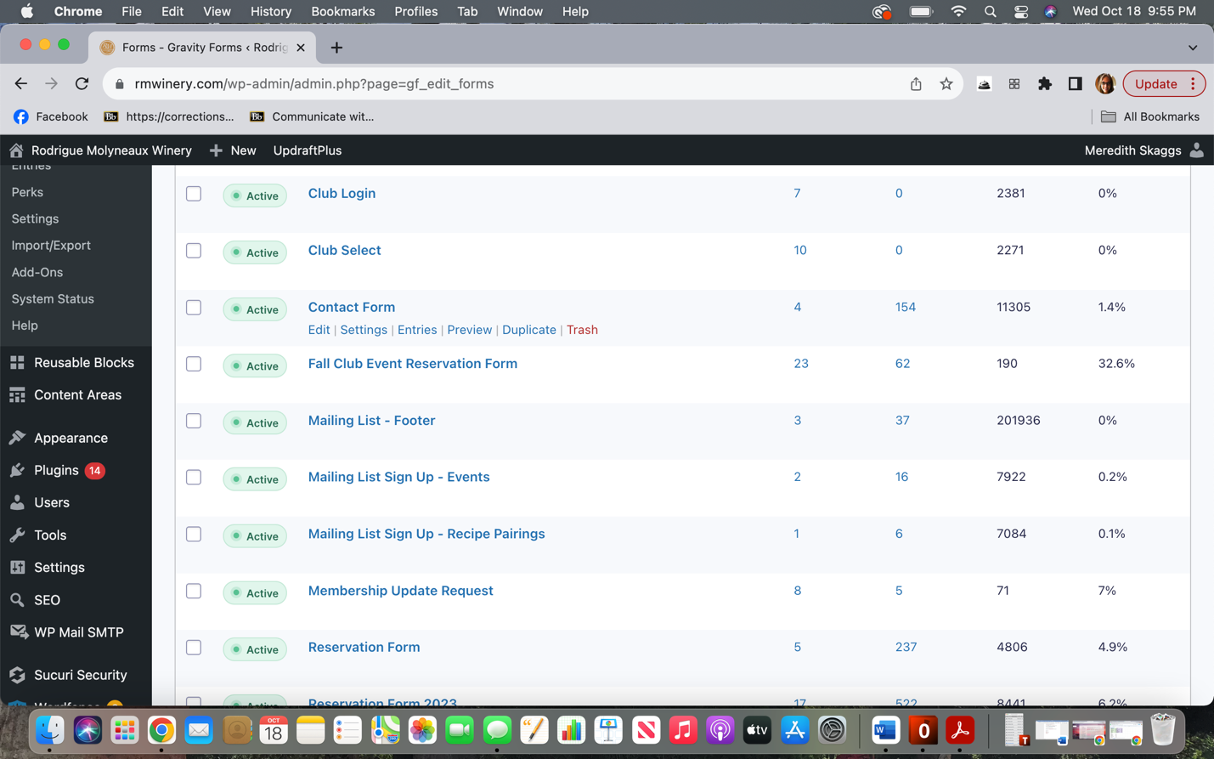

1. Click on “Fall Club Event Reservation Form

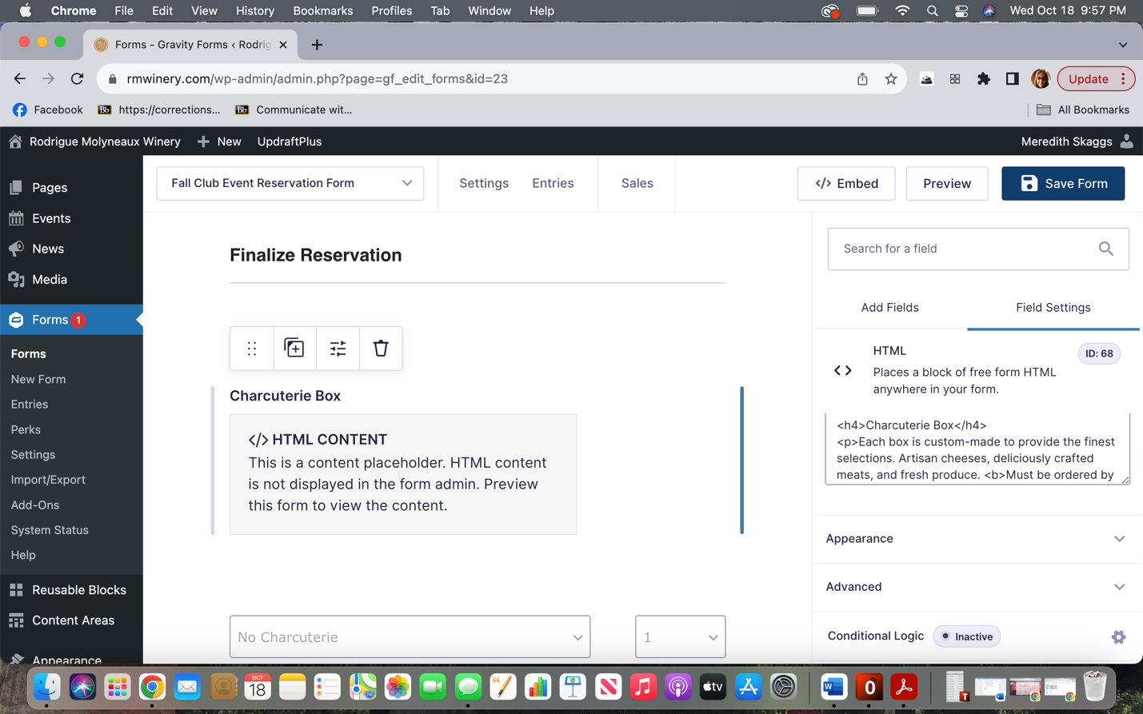

1. Scroll down until you see “Charcuterie Box.” Click on the box, then click on “Conditional Logic” on the right hand of the screen.

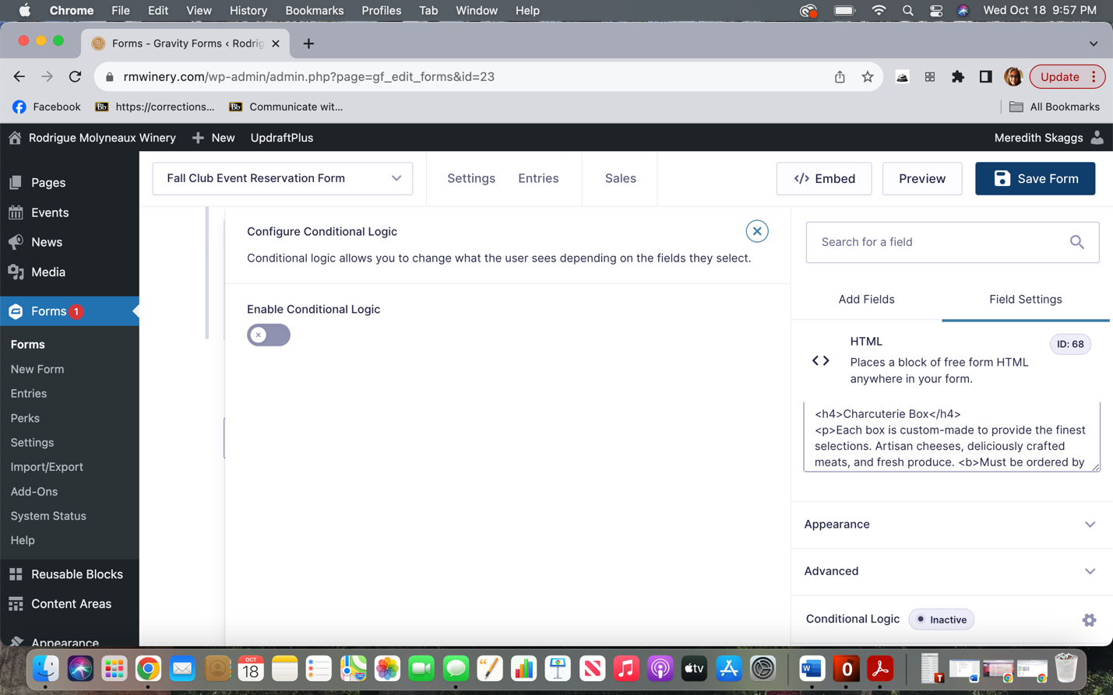

1. Click button below “Enable Conditional Logic”

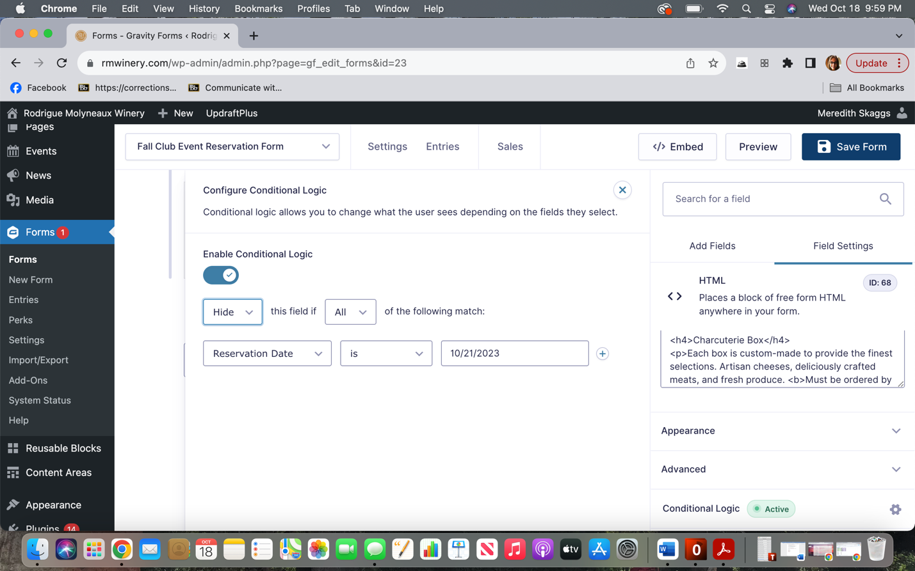

1. Make sure the drop downs match the above.

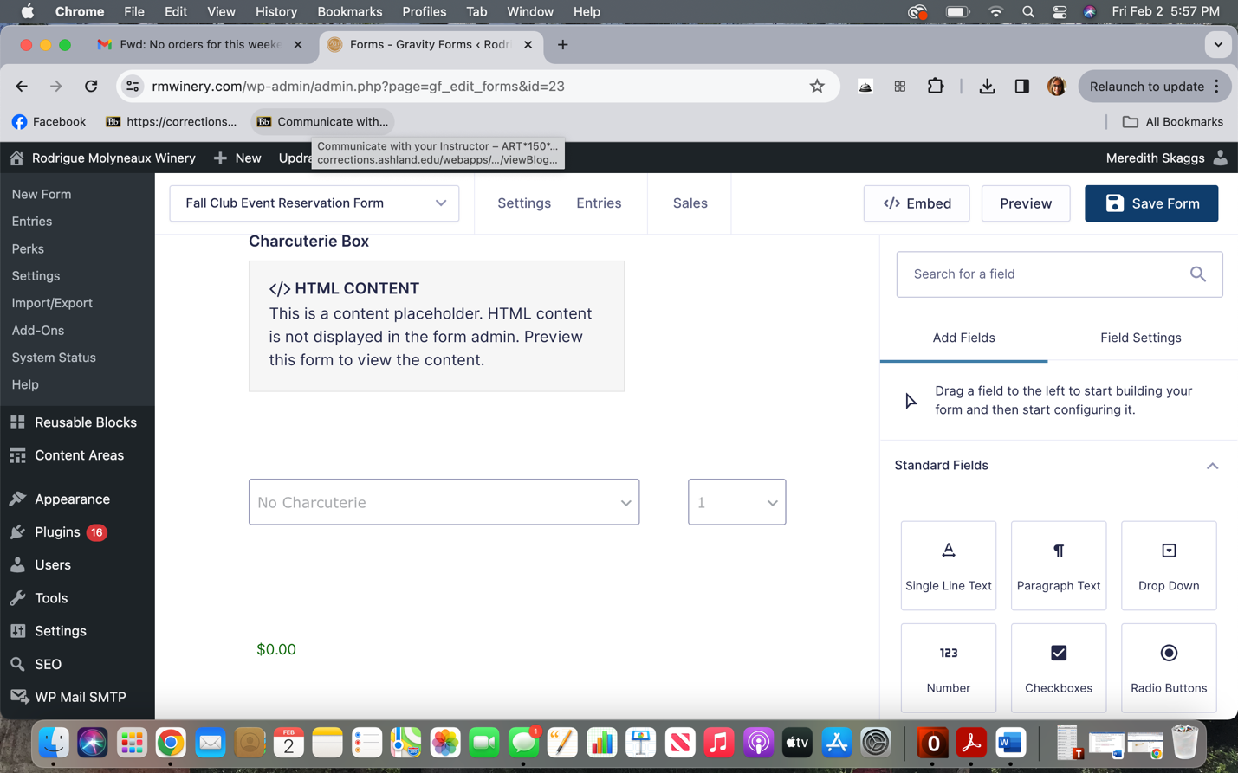

1. Click on the dropdown for that says “No Charcuterie.” Follow steps 3-5 to set up conditional logic
2. Click on the “$0.00” area. Follow steps 3-5 to set up conditional logic.
3. Click “Save Form”